### TCL(commit, rollback, savepoint) & EXPRESSIONS(Boolean, numeric, date)

### TCL - TRANSACTION CONTROL LANGUAGE

* In SQL, TCL stands for **Transaction control language**.
* A single unit of work in a database is formed after the consecutive execution of commands is known as a transaction.
* There are certain commands present in SQL known as TCL commands that help the user manage the transactions that take place in a database.
* **COMMIT. ROLLBACK** and **SAVEPOINT** are the most commonly used TCL commands in SQL.

**1. COMMIT**

COMMIT command in SQL is used to save all the transaction-related changes permanently to the disk. Whenever DDL commands such as INSERT, UPDATE and DELETE are used, the changes made by these commands are permanent only after closing the current session. So before closing the session, one can easily roll back the changes made by the DDL commands. Hence, if we want the changes to be saved permanently to the disk without closing the session, we will use the commit command.

**Syntax:**

**COMMIT**;

**Autocommit is by default enabled in MySQL**. To turn it off, we will set the value of autocommit as 0.

**SET** autocommit = 0;

MySQL, by default, commits every query the user executes. But if the user wishes to commit only the specific queries instead of committing every query, then turning off the autocommit is useful.

Enter password: *********

Welcome to the MySQL monitor. Commands end with ; or \g.

Your MySQL connection id is 20

Server version: 8.0.30 MySQL Community Server - GPL

Copyright (c) 2000, 2022, Oracle and/or its affiliates.

Oracle is a registered trademark of Oracle Corporation and/or its

affiliates. Other names may be trademarks of their respective

owners.

Type 'help;' or '\h' for help. Type '\c' to clear the current input statement.

mysql> create database school;

Query OK, 1 row affected (0.06 sec)

mysql> use school;

Database changed

mysql> CREATE TABLE school(ID INT, SchoolName VARCHAR(40), NumberOfStudents INT, NumberOfTeachers INT, NumberOfClassrooms INT, EmailID VARCHAR(40));

Query OK, 0 rows affected (0.29 sec)

mysql> START TRANSACTION;

Query OK, 0 rows affected (0.00 sec)

mysql> INSERT INTO school(ID, SchoolName, NumberOfStudents, NumberOfTeachers, NumberOfClassrooms, EmailID) VALUES(1, "Boys Town Public School", 1000, 80, 12, "btps15@gmail.com"), (2, "Guru Govind Singh Public School", 800, 35, 15, "ggps25@gmail.com");

Query OK, 2 rows affected (0.07 sec)

Records: 2 Duplicates: 0 Warnings: 0

mysql> ^C

mysql> COMMIT;

Query OK, 0 rows affected (0.36 sec)

mysql> SET autocommit = 0;

Query OK, 0 rows affected (0.00 sec)

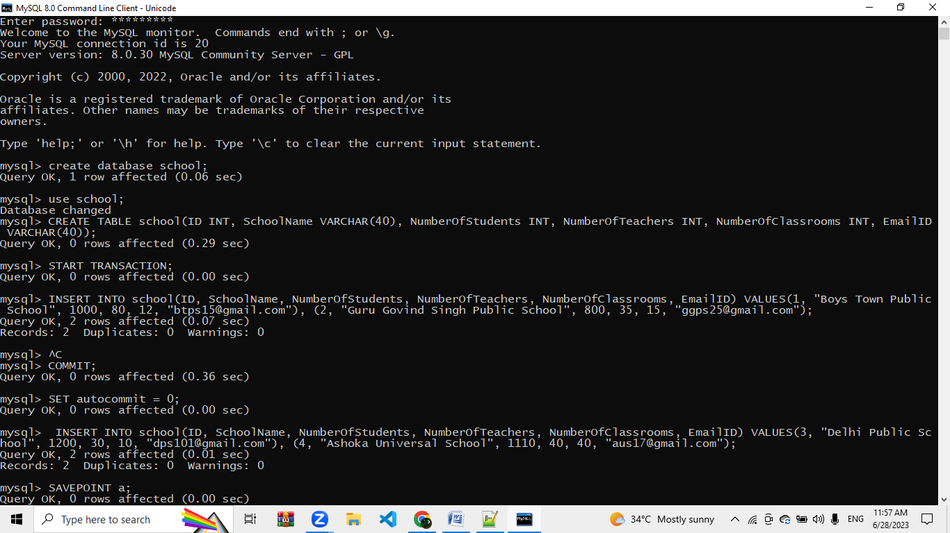

**2. SAVEPOINT**

We can divide the database operations into parts. For example, we can consider all the insert related queries that we will execute consecutively as one part of the transaction and the delete command as the other part of the transaction. Using the SAVEPOINT command in SQL, we can save these different parts of the same transaction using different names.

***For example***, we can save all the insert related queries with the savepoint named INS. To save all the insert related queries in one savepoint, we have to execute the SAVEPOINT query followed by the savepoint name after finishing the insert command execution.

**Syntax:**

SAVEPOINT savepoint_name;

INSERT INTO school(ID, SchoolName, NumberOfStudents, NumberOfTeachers, NumberOfClassrooms, EmailID) VALUES(3, "Delhi Public School", 1200, 30, 10, "dps101@gmail.com"), (4, "Ashoka Universal School", 1110, 40, 40, "aus17@gmail.com");

Query OK, 2 rows affected (0.01 sec)

Records: 2 Duplicates: 0 Warnings: 0

mysql> SAVEPOINT a;

Query OK, 0 rows affected (0.00 sec)

mysql> INSERT INTO school(ID, SchoolName, NumberOfStudents, NumberOfTeachers, NumberOfClassrooms, EmailID) VALUES(4, "Ashoka Universal School", 1110, 40, 40, "aus17@gmail.com"), (5, "Calibers English Medium School", 9000, 31, 50, "cems@gmail.com");

Query OK, 2 rows affected (0.00 sec)

Records: 2 Duplicates: 0 Warnings: 0

mysql> savepoint b;

Query OK, 0 rows affected (0.00 sec)

mysql> select*from school;

+------+---------------------------------+------------------+------------------+--------------------+------------------+

| ID | SchoolName | NumberOfStudents | NumberOfTeachers | NumberOfClassrooms | EmailID |

+------+---------------------------------+------------------+------------------+--------------------+------------------+

| 1 | Boys Town Public School | 1000 | 80 | 12 | btps15@gmail.com |

| 2 | Guru Govind Singh Public School | 800 | 35 | 15 | ggps25@gmail.com |

| 3 | Delhi Public School | 1200 | 30 | 10 | dps101@gmail.com |

| 4 | Ashoka Universal School | 1110 | 40 | 40 | aus17@gmail.com |

| 4 | Ashoka Universal School | 1110 | 40 | 40 | aus17@gmail.com |

| 5 | Calibers English Medium School | 9000 | 31 | 50 | cems@gmail.com |

+------+---------------------------------+------------------+------------------+--------------------+------------------+

6 rows in set (0.00 sec)

mysql> INSERT INTO school(ID, SchoolName, NumberOfStudents, NumberOfTeachers, NumberOfClassrooms, EmailID) VALUES(5, "Boys Town Public School", 1000, 80, 12, "btps15@gmail.com"), (6, "Guru Govind Singh Public School", 800, 35, 15, "ggps25@gmail.com");

Query OK, 2 rows affected (0.00 sec)

Records: 2 Duplicates: 0 Warnings: 0

mysql> select*from school;

+------+---------------------------------+------------------+------------------+--------------------+------------------+

| ID | SchoolName | NumberOfStudents | NumberOfTeachers | NumberOfClassrooms | EmailID |

+------+---------------------------------+------------------+------------------+--------------------+------------------+

| 1 | Boys Town Public School | 1000 | 80 | 12 | btps15@gmail.com |

| 2 | Guru Govind Singh Public School | 800 | 35 | 15 | ggps25@gmail.com |

| 3 | Delhi Public School | 1200 | 30 | 10 | dps101@gmail.com |

| 4 | Ashoka Universal School | 1110 | 40 | 40 | aus17@gmail.com |

| 4 | Ashoka Universal School | 1110 | 40 | 40 | aus17@gmail.com |

| 5 | Calibers English Medium School | 9000 | 31 | 50 | cems@gmail.com |

| 5 | Boys Town Public School | 1000 | 80 | 12 | btps15@gmail.com |

| 6 | Guru Govind Singh Public School | 800 | 35 | 15 | ggps25@gmail.com |

+------+---------------------------------+------------------+------------------+--------------------+------------------+

8 rows in set (0.00 sec)

mysql> savepoint c;

Query OK, 0 rows affected (0.00 sec)

mysql> update school set NumberOfStudents=666 where id=5;

Query OK, 2 rows affected (0.03 sec)

Rows matched: 2 Changed: 2 Warnings: 0

mysql> select*from school;

+------+---------------------------------+------------------+------------------+--------------------+------------------+

| ID | SchoolName | NumberOfStudents | NumberOfTeachers | NumberOfClassrooms | EmailID |

+------+---------------------------------+------------------+------------------+--------------------+------------------+

| 1 | Boys Town Public School | 1000 | 80 | 12 | btps15@gmail.com |

| 2 | Guru Govind Singh Public School | 800 | 35 | 15 | ggps25@gmail.com |

| 3 | Delhi Public School | 1200 | 30 | 10 | dps101@gmail.com |

| 4 | Ashoka Universal School | 1110 | 40 | 40 | aus17@gmail.com |

| 4 | Ashoka Universal School | 1110 | 40 | 40 | aus17@gmail.com |

| 5 | Calibers English Medium School | 666 | 31 | 50 | cems@gmail.com |

| 5 | Boys Town Public School | 666 | 80 | 12 | btps15@gmail.com |

| 6 | Guru Govind Singh Public School | 800 | 35 | 15 | ggps25@gmail.com |

+------+---------------------------------+------------------+------------------+--------------------+------------------+

8 rows in set (0.00 sec)

mysql> savepoint d;

Query OK, 0 rows affected (0.00 sec)

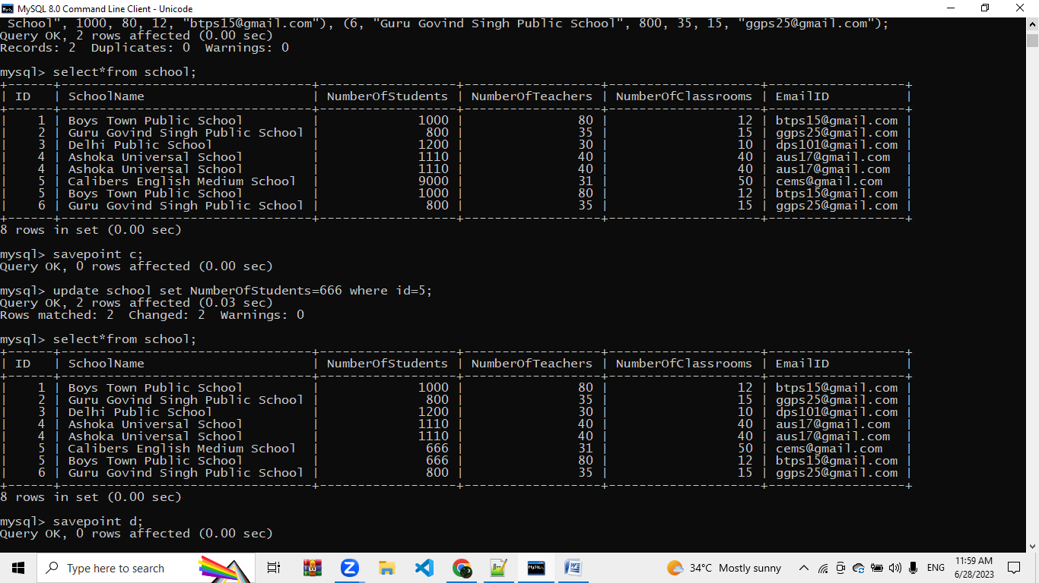

**3. ROLLBACK**

While carrying a transaction, we must create savepoints to save different parts of the transaction. According to the user's changing requirements, he/she can roll back the transaction to different savepoints.

*Consider a scenario*: We have initiated a transaction followed by the table creation and record insertion into the table. After inserting records, we have created a savepoint INS. Then we executed a delete query, but later we thought that mistakenly we had removed the useful record. Therefore in such situations, we have an option of rolling back our transaction. In this case, we have to roll back our transaction using the *ROLLBACK* command to the savepoint INS, which we have created before executing the DELETE query.

**Syntax:**

**ROLLBACK** **TO** savepoint_name;

mysql> ROLLBACK TO c;

Query OK, 0 rows affected (0.00 sec)

mysql> select*from school;

+------+---------------------------------+------------------+------------------+--------------------+------------------+

| ID | SchoolName | NumberOfStudents | NumberOfTeachers | NumberOfClassrooms | EmailID |

+------+---------------------------------+------------------+------------------+--------------------+------------------+

| 1 | Boys Town Public School | 1000 | 80 | 12 | btps15@gmail.com |

| 2 | Guru Govind Singh Public School | 800 | 35 | 15 | ggps25@gmail.com |

| 3 | Delhi Public School | 1200 | 30 | 10 | dps101@gmail.com |

| 4 | Ashoka Universal School | 1110 | 40 | 40 | aus17@gmail.com |

| 4 | Ashoka Universal School | 1110 | 40 | 40 | aus17@gmail.com |

| 5 | Calibers English Medium School | 9000 | 31 | 50 | cems@gmail.com |

| 5 | Boys Town Public School | 1000 | 80 | 12 | btps15@gmail.com |

| 6 | Guru Govind Singh Public School | 800 | 35 | 15 | ggps25@gmail.com |

+------+---------------------------------+------------------+------------------+--------------------+------------------+

8 rows in set (0.00 sec)

mysql> rollback to b;

Query OK, 0 rows affected (0.03 sec)

mysql> select*from student;

ERROR 1146 (42S02): Table 'school.student' doesn't exist

mysql> select*from school;

+------+---------------------------------+------------------+------------------+--------------------+------------------+

| ID | SchoolName | NumberOfStudents | NumberOfTeachers | NumberOfClassrooms | EmailID |

+------+---------------------------------+------------------+------------------+--------------------+------------------+

| 1 | Boys Town Public School | 1000 | 80 | 12 | btps15@gmail.com |

| 2 | Guru Govind Singh Public School | 800 | 35 | 15 | ggps25@gmail.com |

| 3 | Delhi Public School | 1200 | 30 | 10 | dps101@gmail.com |

| 4 | Ashoka Universal School | 1110 | 40 | 40 | aus17@gmail.com |

| 4 | Ashoka Universal School | 1110 | 40 | 40 | aus17@gmail.com |

| 5 | Calibers English Medium School | 9000 | 31 | 50 | cems@gmail.com |

+------+---------------------------------+------------------+------------------+--------------------+------------------+

6 rows in set (0.00 sec)

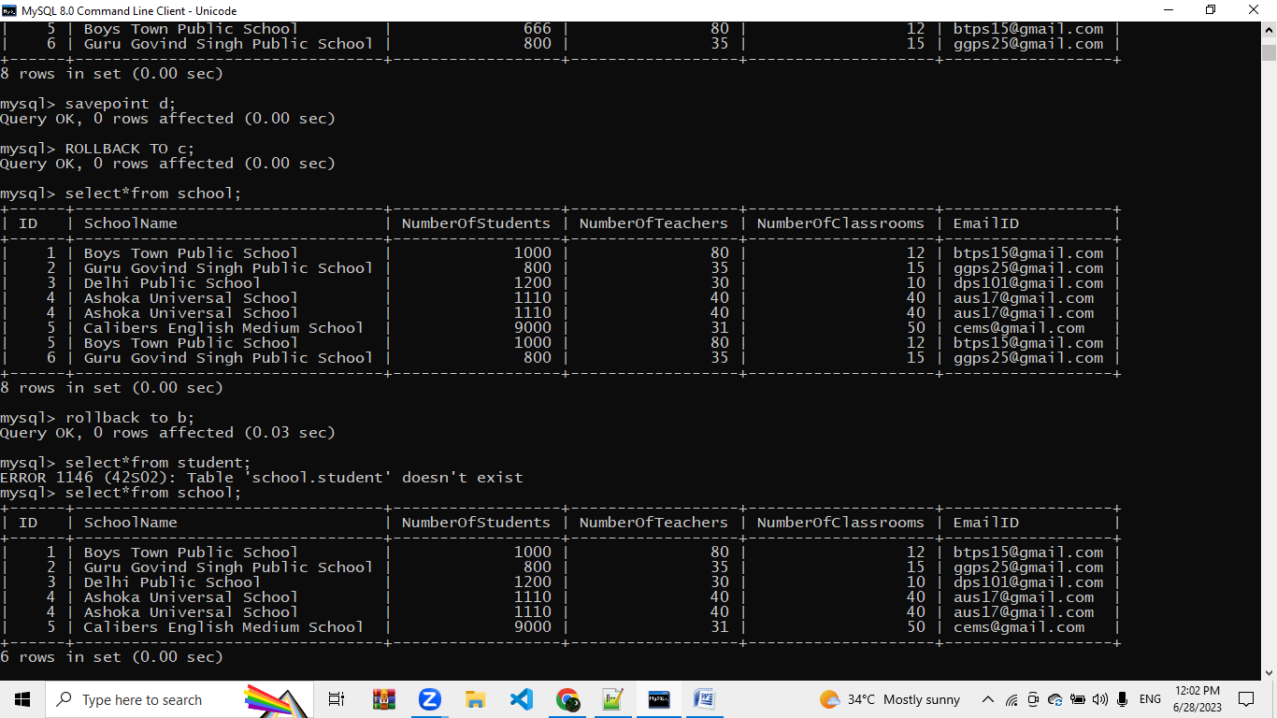

**Expressions**

1. **Boolean Expressions**

**mysql> select*from school;**

**+------+---------------------------------+------------------+------------------+--------------------+------------------+**

**| ID | SchoolName | NumberOfStudents | NumberOfTeachers | NumberOfClassrooms | EmailID |**

**+------+---------------------------------+------------------+------------------+--------------------+------------------+**

**| 1 | Boys Town Public School | 1000 | 80 | 12 | btps15@gmail.com |**

**| 2 | Guru Govind Singh Public School | 800 | 35 | 15 | ggps25@gmail.com |**

**| 3 | Delhi Public School | 1200 | 30 | 10 | dps101@gmail.com |**

**| 4 | Ashoka Universal School | 1110 | 40 | 40 | aus17@gmail.com |**

**| 4 | Ashoka Universal School | 1110 | 40 | 40 | aus17@gmail.com |**

**| 5 | Calibers English Medium School | 9000 | 31 | 50 | cems@gmail.com |**

**+------+---------------------------------+------------------+------------------+--------------------+------------------+**

**6 rows in set (0.00 sec)**

**mysql> select*from school where EmailID='btps15@gmail.com';**

**+------+-------------------------+------------------+------------------+--------------------+------------------+**

**| ID | SchoolName | NumberOfStudents | NumberOfTeachers | NumberOfClassrooms | EmailID |**

**+------+-------------------------+------------------+------------------+--------------------+------------------+**

**| 1 | Boys Town Public School | 1000 | 80 | 12 | btps15@gmail.com |**

**+------+-------------------------+------------------+------------------+--------------------+------------------+**

**1 row in set (0.00 sec)**

1. **Numerical expressions**

**select(1000+800) as addition;**

**+----------+**

**| addition |**

**+----------+**

**| 1800 |**

**+----------+**

**1 row in set (0.06 sec)**

**mysql> select count(*)as"Records" from school;**

**+---------+**

**| Records |**

**+---------+**

**| 6 |**

**+---------+**

**1 row in set (0.16 sec)**

